Ordering Nuts

Be sure to tell your customers:
All nuts are this year’s crop!
All products are in 1lb packages, except tins vary
Roasting is in 100% Peanut Oil.

Four price changes:
Walnut Halves & Pieces went down to $8
Apricots went down to $6
Cashew-n-stix tins went up $1 each.

Use the attached form to collect your orders.
Enter customer name in first column.
Indicate the number of each type of nut/mix in the box on the column for that nut/mix.
Total for the customer.

Submit orders by 5 pm Friday pick-up available following Wed or Thur.
Nov 9 = 14/15
Nov 16 = 20/21(Thanksgiving week)
Nov 23 = 28/29
Nov 30 = Dec 5/6
Dec 7 = 12/13
Dec14 = 19/21

You will be asked to sign for your nuts when you pick them up. You are responsible for collecting for your nut orders, preferably when order is placed. Payments for nuts are due within two weeks after pick-up at the latest.

If you are able to take orders but not deliver, there are volunteers to deliver your orders locally. You should collect at the time you take the order, so the delivery person can just drop them off. (Call Ruth if you need a delivery person. 940-765-4038 Leave a message if I don’t answer. I’ll call you back.)

If someone wants a special order (i.e., no salt), write it down and I will see what I can do. No guarantees.

Please tally your own orders and give me (email me) the tally sheet. I do not want to be responsible for your individual orders.
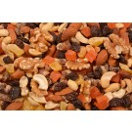  Hawaiian Trail Mix $7.00  - Natural Whole Almonds  - Diced Pineapple  - Diced Papaya  - Diced Dates  - Raisins  - Walnut Halves & Pieces  - Blanched Peanuts  - Cashew Pieces | 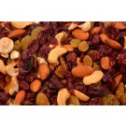  Roasted Berry Trail Mix $7.00  - Cranberries  - Golden Raisins  - Cashew Pieces  - Almonds (Roasted/Salted)  - Peanut Oil and Salt
Texas Party Mix $6.00  - Gems (Similar to M & M's)  - Blanched Peanuts  - Thompson Raisins  - Cashew Splits  - Honey Roasted Peanuts  (Roasted/Salted) | 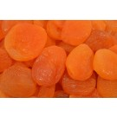  Apricots – Sun Dried Whole $6.00  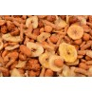Honey Roasted Mix $6.00  NEW!  Honey Roasted peanuts, banana chips, butter toffee peanuts & sesame sticks.
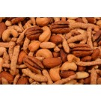  Cashew-N-Stix Mix $9.00  - Whole Cashews  - Sesame Sticks  - Pecan Halves  - Natural Whole Almonds  - Peanut Oil and Salt  * * * * * * * * * * * * * *  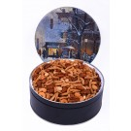  Mix in a Currier & Ives picturesque gift tin. comes with box for mailing or wrapping  14oz = $15 24oz = $20  Gift Tins | 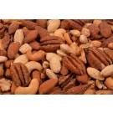  Texas Deluxe Mix $10.00  - Whole Cashews  - Natural Whole Almonds  - Pecan Halves  - Blanched Whole Almonds  - Peanut Oil and Salt  * * * * * * * * * * * * * *  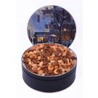  Mix in a Currier & Ives picturesque gift tin. Comes with box for mailing or wrapping  1# = $17 29 oz = $26  Gift Tins
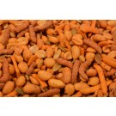  Cajun Mix $5.00  - Hot and Spicy Peanuts  - Pumpkin Seeds  - Hot Cajun Corn Sticks  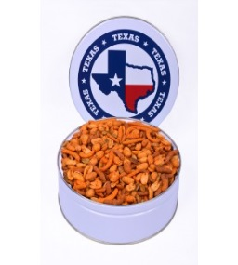  - Cheddar Sesame Sticks  * * * * * * * * * * * * * *  26 oz. of mix in a gift tin emblazoned with the State of Texas. $15 comes with box for mailing or wrapping | 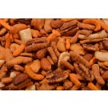  Melrose Mix $7.00  - Almonds Cashews  - Cheddar Sticks Rice Crackers  - Pecan Halves  - Hot Cajun Corn Sticks  - Peanut Oil and Salt  * * * * * * * * * * * * * * * * * * * * * * *  27 ounces of mix in a Currier & Ives picturesque gift tin. $19 comes with box for mailing or wrapping

